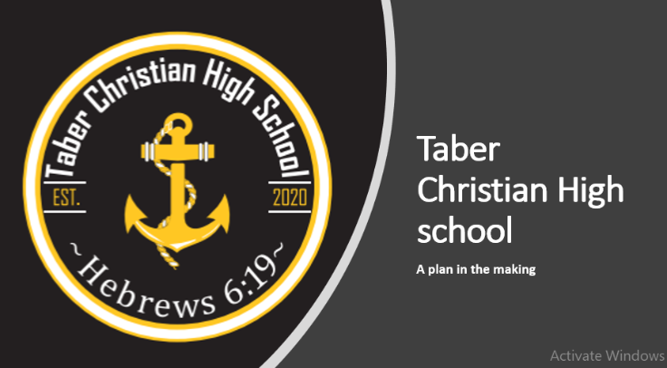
“Anchored to Hope” - Hebrews 6:19
Taber Christian High school; Taber Christian High school @ Jason Visser 15

“Whether you think you can or think you can’t - you are right”
-Henry Ford

Taber Christian High School News and Notes:
January 25, 2021 - January 31, 2021

Monday, January 25 - Science Exam
Tuesday, January 26 - Social Exam
Wednesday, January 27 - Mon/Wed Option Assessments 9 am
Tues/Thurs Option Assessments 10:30 am
Ice fishing orientation (11:30 - 12:15)
Thursday, January 28 - First Aid Training (theory)
Friday, January 29 - TCHS Ice Fishing Trip - Lost Lake

School Year Calendar 2020-2021
Important Dates:
February 1 2nd Semester begins
February 1 and 2 - First Aid Training (practical)
February 15-19 - No School for Students
March 05 - School Based PD Day - no students
March 08 - Division Wide PD Day - no students
March 18 - School Based Parent/Teacher Interviews - after school
April 2-9 - Division Wide Holiday - no students, no staff
May 7 - School Based PD Days (all schools) - no students
May 21 - School Based Unassigned Teacher Time - no students, no staff
May 24 - Division Wide Holiday - no students, no staff
June 25 - Last day of School - Sr. High

TCHS First Aid training
- Will be offering First Aid Training through St. John
Ambulance: Theory - Jan 28. Please note that this portion will be done online but at the school. Students are expected to come to school this day. The theory portion has to be completed before the practical portion.
Practical - Feb 1 and 2
- Students are able to earn school credits for the training
- Cost for program (through St John’s ambulance) is
(School is covering 50% of the actual cost)
** Students were given an information sheet including payment information. Please return the bottom portion and the payment to the School Office by January 28. Thank-you!

Ice Fishing at Lost Lake - Please make sure to fill out and hand in your consent form for this activity. This needs to be returned in order to go on the trip!!

Exam Week

The final exam schedule for semester 1 courses will take place January 26 - 28. All exams begin at 9am (after devotions).

Monday, January 25 - Science Exam
Tuesday, January 26 - Social Exam
Wednesday, January 27 - Mon/Wed Option Assessments 9 am
Tues/Thurs Option Assessments 10:30 am
Ice fishing orientation (11:30 - 12:15)
Thursday, January 28 - First Aid Training (theory)
Friday, January 29 - TCHS Ice Fishing Trip - Lost Lake

**Note: during exam week, students will be excused once their exam / course
work is completed. Buses will still be running this week in case students
cannot find rides to get home early.
**Note: Thursday’s First Aid Training is expected to take most of the school day.

Semester II Update:
- As we start semester 2 (quarter 3), we will begin new options courses.
On Monday/Wednesday students will have the option between
Foods: Intro to Baking or Introduction to Tourism
(note: Foods class has a course fee of $20)
On Tuesday/Thursday, students will have the option between
Photography: Exposure or Cardiovascular system
- Starting in semester 2, Mr. Phil Vriend will be taking over teaching PE and will be teaching Career and Life Management (CALM)
-this allows administration some release time to help with the planning / contributing to the new TCHS building (more information to follow).

Looking ahead to next year!
By the end of the month, we will be sending home a letter asking each student’s intent to register for the next school year! We look forward to offering an excellent grade 11 program at TCHS next year. Stay tuned!

● The office phone number for the High School is 403-359-3835. Please feel free to phone. If we are not in the office, please leave a message and we will do our best to check regularly. Please call the office if your child will be late or absent from school. This information is required for us to enter into PowerSchool for the Head Office to monitor. Thank-you!
The Joyful Servers sent home an order form for Panago Pizza Vouchers and IGA cards. Please consider supporting this fundraiser! All proceeds go to the building of the new High School!!

Taber Society for Christian Education would like to inform you. If you are choosing to e-transfer donations or tuition, the finance committee has set a designated email:
tcssocietyfinance@gmail.com

