TCHS School Council Meeting
Monday, December 06, 2021
7pm

Staff Present: Jason Visser, Tanya Hoekstra, Kim Scheurkogel

15 parents representing 10 families were present.

1 – grade 11 student was also present.

Opening/Welcome: Jason Visser (principal) opened with devotions and prayer. The devotions were taken from “The Jesus I Never Knew” by Philip Yancy.

TCHS Mission and Vision:
Grade 10 students have helped out at Street’s Alive over the past two weeks. The work involved was sorting through donations and organizing them into boxes - making it easier for people who need clothing to find what they are looking for. After working in the morning, a Street’s Alive representative talked to the students about their work and the needs they try to meet. Julie Kissick, one of the co-founders of Street’s Alive, shared that “hope” is the most powerful thing they can offer. She added that real hope can only be found in Jesus Christ. As a result, this is the rock on which their ministry is based. This experience ties in well with grade 10 Christian Studies, in that students are working though what it means to recognize all people as image bearers!

Image Bearing: Matthew 25:37-40:
³⁷ “Then the righteous will answer him, ‘Lord, when did we see you hungry and feed you, or thirsty and give you something to drink? ³⁸ When did we see you a stranger and invite you in, or needing clothes and clothe you? ³⁹ When did we see you sick or in prison and go to visit you?’
⁴⁰ “The King will reply, ‘Truly I tell you, whatever you did for one of the least of these brothers and sisters of mine, you did for me.’

What is School Council?
- Forum for parents to learn about school activities and plans
- Opportunity for parents to ask questions about school
- Something mandated by Alberta education
- Can take a variety of formats
-TCHS School council representative: Mrs. Christine Oosterhof

Strategic Priorities - Strong Instruction:
- Principal and teacher engage in generative dialogue in an attempt to continue to develop a culture of meaningful teaching and learning.
- Utilization of CREW - effort to develop relationships and learning across for all members of the school community.
- Staff are committed to ongoing professional learning in areas of TFT, differentiation, and experiential learning.

Christ Centered Learning Environment:
- CREW Time - Tuesdays and Fridays - includes self reflection, group reflection, games, challenges, future dreams, identities in Christ, prayer items etc.
- This year students have helped select the theme: “The Way” (Hebrews 6:19). We are developing a visual to go along with this and be a focal point in our classroom.

Experiential Learning:
- Service Learning: Taber food bank drive, work with Streets Alive, Voice of martyrs, Volunteer with Taber and District adult learning; Lethbridge Correctional Center - Christmas cards/letters.
- Other trips/experiences - PE (curling, climbing center, taekwondo, swimming, etc)
- Mentorship Program - TCHS students gain experience as mentors.

Athletics Update:
Volleyball season wrapped up: Thanks to the athletes and volunteer coaches for an excellent first season!
Basketball season is underway: TCHS Men’s SV team is competing in the “River Ridge Basketball” league and TCHS girls playing on the St. Mary’s team.

Chapel:
Thursday, Dec 16 - TCHS Christmas Assembly @ 9am (parents invited)
Parents are asked to email jason.visser@horizon.ab.ca if interested in coming.

Friday, Dec 17 - TCHS Pancake Breakfast (9 am)
Student tour of new TCHS facility (under construction) 1pm. (parents invited) Please email jason.visser@horizon.ab.ca
-Christmas CREW quiz challenge activity

Discussion Section:

Question: Does TCHS adopt the practice of having “half-day” Fridays in the 2022/23 school year and beyond?

Reasons for holding the discussion:
- TCHS school year will go until the end of June (this cannot be changed due to diploma exams in Grade 12 being scheduled at this time).
- Is there a way that we can give students an even better chance of being successful in school?

Positives of a “half-day” Friday scheduling option
- Allows us to participate more seamlessly in Co-curricular
  - Currently when sports teams are gone (Friday afternoons), changes the dynamic of classes (more subs with TCHS staff coaching/supervising sports, half full classes).
  - Students in athletics miss classes
  - TCHS staff are gone, requires coverage for classes (not class teacher)
- Allows us to still have a 5 day week (frequency/repetition of learning Friday would be core-classes).
- Allows students to have a “breather” in terms of engaging in high level content
- Allows staff time to plan/meet
- Allows us to utilize Horizon bussing

Half Day Friday Schedule:

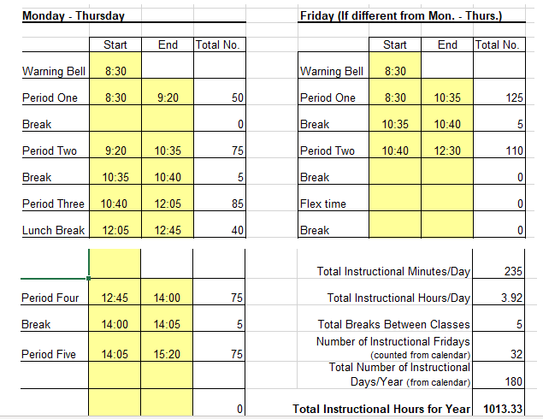
Full Day Friday Schedule:
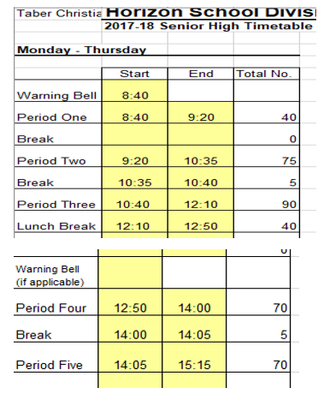
Positives of a “full-day” Friday scheduling option:
- People who live farther from school will travel for a full day instead of a half day. May be a bigger issue for people who live farther away
- Consistent bell times for Monday - Friday. Students know what is expected of them on all days.
- Less likely to miss Fridays
- Schedule more in-line with Taber Christian school schedule
- 5 additional days off

Questions/Comments/Thoughts:
- Question: How does this all work with bussing with Horizon? Jay indicated that he has been in contact with Horizon and have received indication that it would work fine to make bussing work on half days.
- Question: Will TCS is also going to be implementing the same thing. Jay answered that this has nothing to do with TCS - that this scheduling decision is for the high school only.
- Question: asked what “out-of-town” students will do when they wait for the TCS bus on Friday’s? Jay answered that the high school doors would stay open for a time in the afternoon so students would be able to do school work etc. High school students could carpool or hang out with friends as well.
- Question: When would this start? It would start for the next school year (2022/2023) but not before. First, this needs to be approved by TCHS school council. Then we take it to the Horizon board and they would organize a larger community meeting.
- Question: Do we vote for one or the other or is there an option for it to stay the same as this year? Jay answered that it would be one or the other, but the schedule would change for next year (meaning we would go later in the day on Mon – Thursday)
- Question: Will others who are not here get to vote as well? Jay answered that he will be following up with Wilco regarding the vote but we will likely have to reach out to parents who are not here to be given the option to vote. We need to have a ⅔ majority to move to a certain direction.
- Comment – A parent shared his perspective and experience with having a child at a school with half day Fridays. He said it was especially beneficial with the sports program. It allowed his kids to play sports and not miss out on too much or any school work. Many tournaments/games are scheduled for Friday afternoons. He also mentioned that it may be beneficial to stay consistent with other Horizon schools and high schools in Taber. If we don’t move to half day Fridays right away, we would likely need to revisit the idea in the near future.
- Question: How will this “half-day” schedule work with Horizon bussing since the buses meet at the loop at noon? Jay answered that this proposed half day schedule is not set in stone. This is just to give an idea of what it may look like and that it would be tweaked to make use of the Horizon bussing.

Voting:
Ballots were passed out - 1 per family. The option was to select either: Monday-Friday (full days) or Monday-Thursday (full days and half day Fridays).

Ballots were collected. Eight votes were in favor or going to half day Fridays and two votes were opposed.

Meeting closed at 8pm.

